To implement this project we are using 4 input images given in paper and on reference image. Below are the images screen shots saved inside images folder

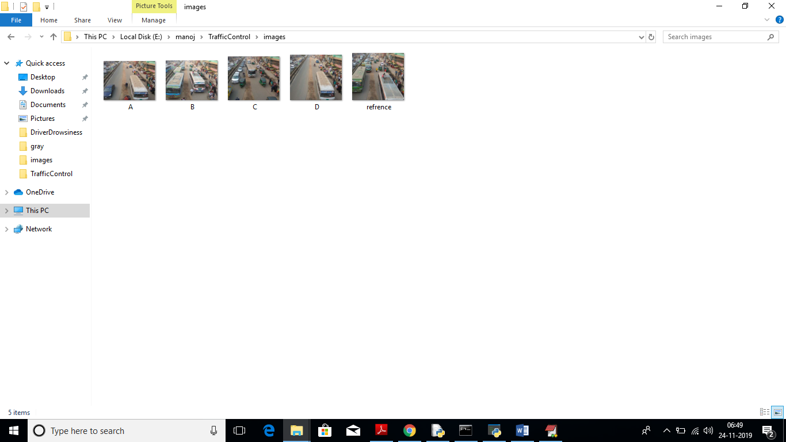

We can upload above 4 images to application to calculate traffic signal time.

Screen shots

To run this project double click on ‘run.bat’ file to get below screen

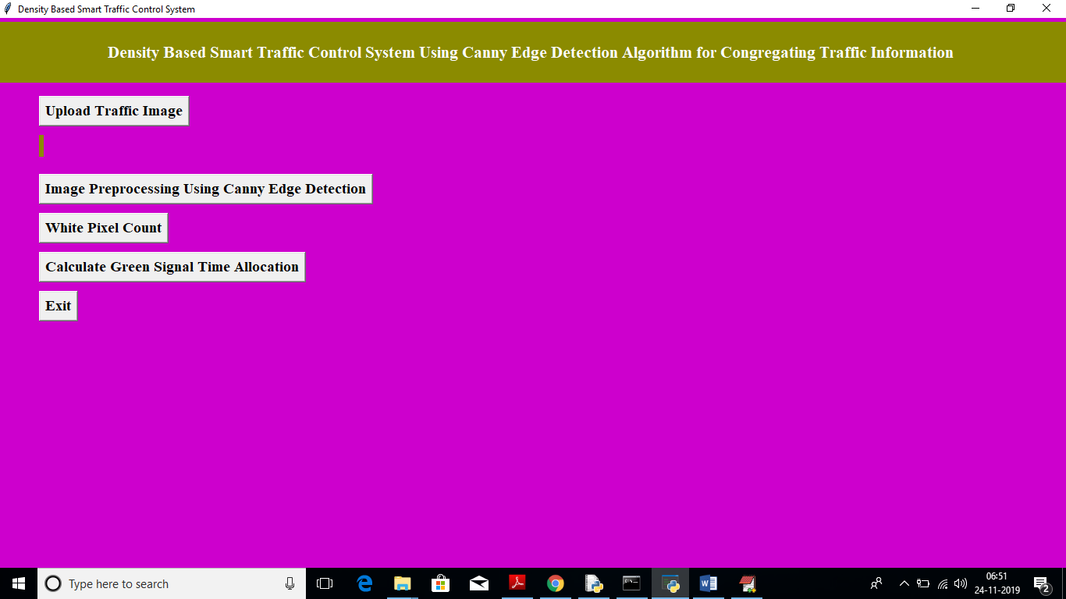

In above screen click on ‘Upload Traffic Image’ button to upload image.

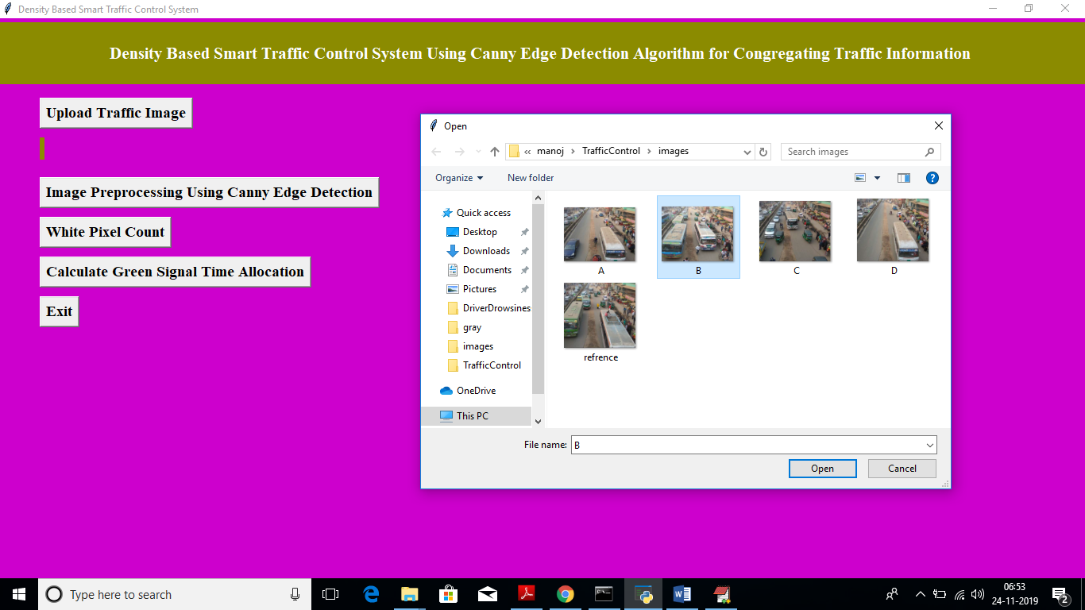

In above screen I am uploading image B and now click on ‘Open’ button to load image

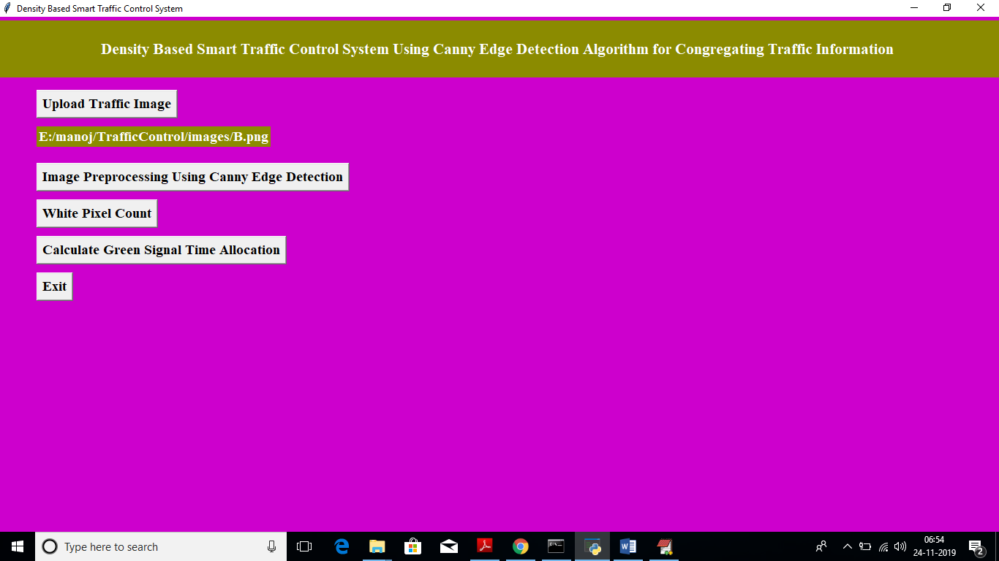

In above screen we got message as input image loaded. Now click on ‘Image Pre-processing Using Canny Edge Detection’ button to apply Gaussian filter and to get canny edges, after clicking button wait for few seconds till you get below screen with edges

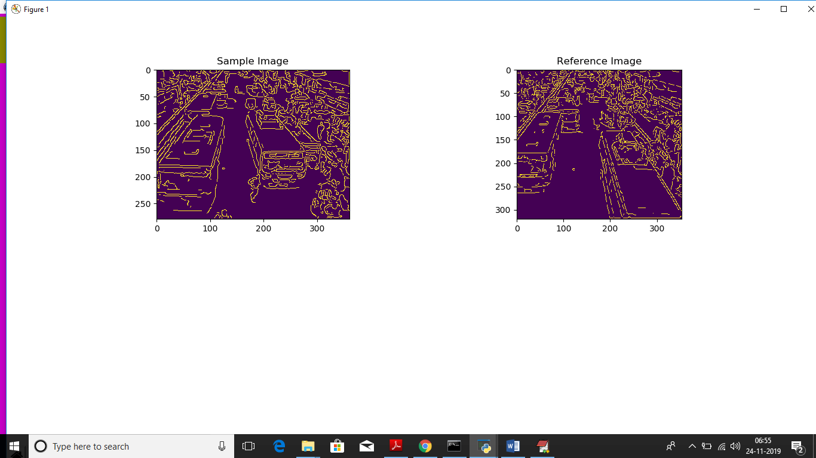

In above screen left side image is the uploaded image and right side is the ‘Reference Image’, Now close this above screen and click on ‘White Pixel count’ button to get white pixels from both images

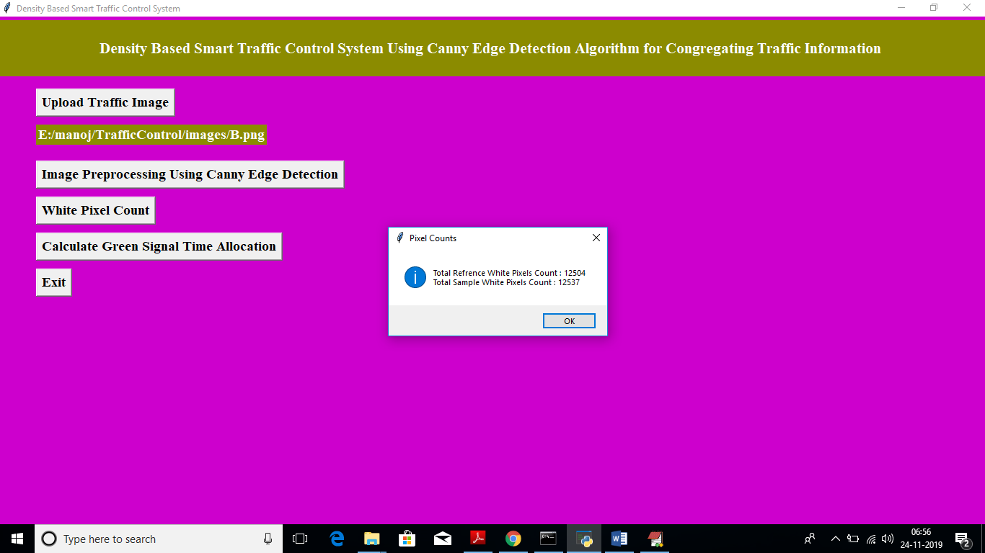

In above screen dialog box we can see total white pixels found in both sample and reference image. Now click on ‘Calculate Green Signal Time Allocation’ button to get signal time

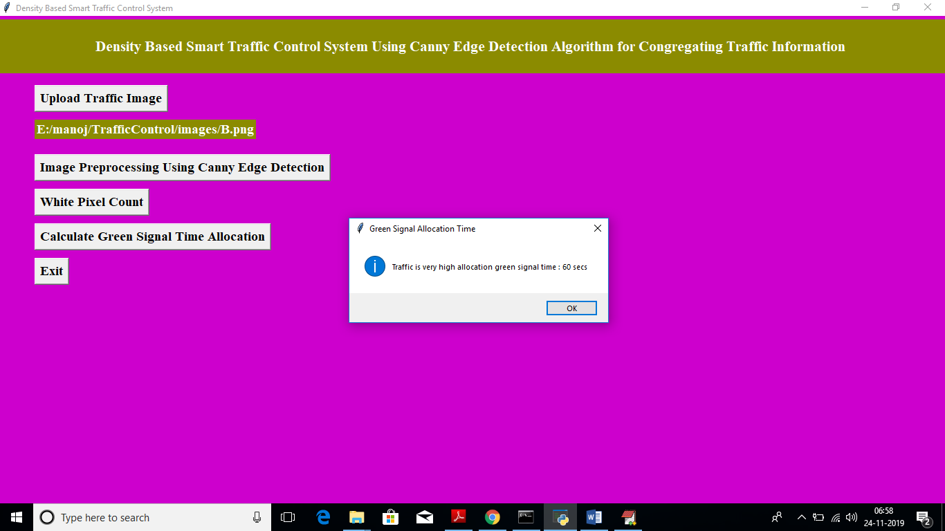

For that uploaded image we got message as it contains high traffic and signal time must be 60 seconds. Similarly you can upload any image and get output. Below is the output for image A

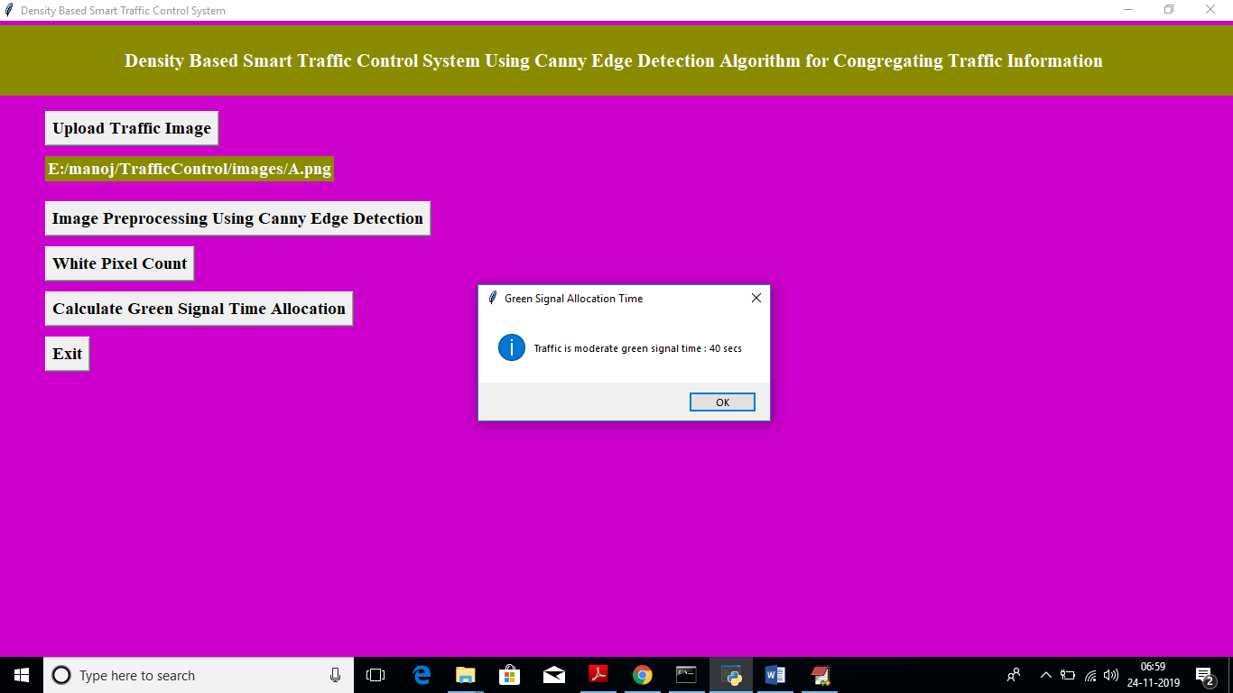

Above time for image A